

**Quick 7-step guide to making a claim on mySelf** for **Extra Curriculum Payments**

1. Log on to your  account [(www.northlanarkshire.gov.uk/myself)](http://www.northlanarkshire.gov.uk/myself)

**Remember**: your **Username** is your employee reference number.

# Go to Pay & Benefits



# Click on + Add claim in the Time & Expenses section



1. Input the **Start date** (claim date). Also, add **Job title** & **Claim Template** as shown below:

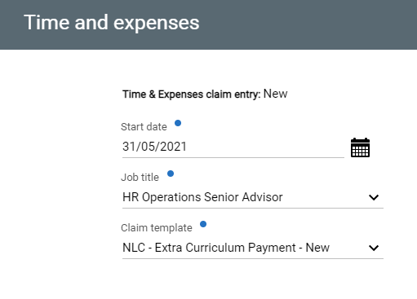 Then click 

1. Populate all the information below on the following page. (Guidance links are available on this page if more information required).

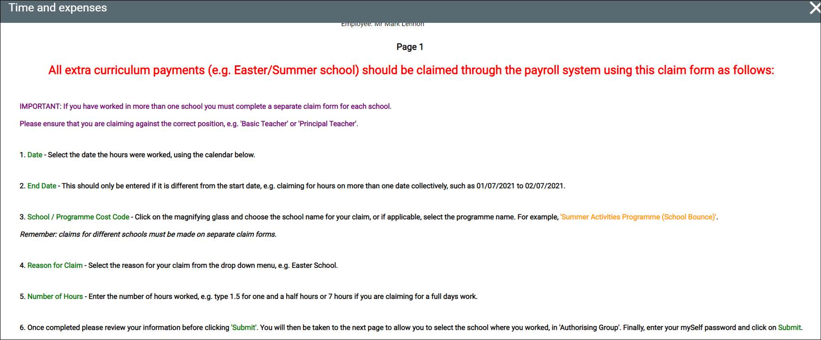

**Element Code** – The only element now used is **331 Extra Curriculum Payment**.

**Date** – should be date completed the overtime (DD/MM/YYYY).

**End Date** should be input if different from the Start Date (DD/MM/YYYY)

**Cost Code –** Enter the cost code by selecting magnifying glass & choosing the school you worked in. Please ensure any claims for different schools are on separate claims.

**Reason for Claim** is either Digital Activity, Easter School, Summer School, Home Tuition or Supported Study. Please choose which is applicable to your claim.

**Number of Hours** is total number of hours worked. (Note: please remember to deduct any breaks)

Once this is all completed, please click 

1. On this new page that appears (screenshot below)

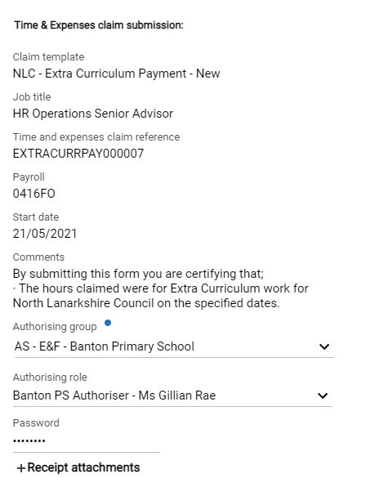

a) select the **Authorising group**, this will be the school you worked in

b) Then select **Authorising role** and select the Authorising Managers name in the establishment in which you worked.

c) Please enter your  password

Once completed, select 

The manager you selected will now receive a notification to view/authorise your claim as applicable. You can view the status of your claim in the **Pay & Benefits** / **Time & Expenses section** on mySelf.

**Please Note** :- A claim that states ‘Provisional’ means that the claim has **NOT** been sent to the Authorising Manager. You must click into this claim and submit it to be paid for it.