Asset & Procurement Solutions

Flexi Desk Booking System

Buildings with

Flexible booking desks

Prepared By
Asset Team
December 2020

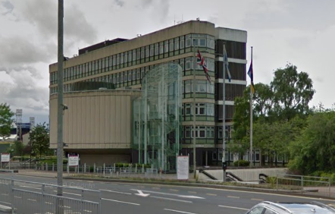 | Civic Centre, Windmillhill Street, Motherwell ML1 1AB  Floors: 5 (Ground – Third)  Bookable desks: 240  Reception: Yes  Parking: Yes
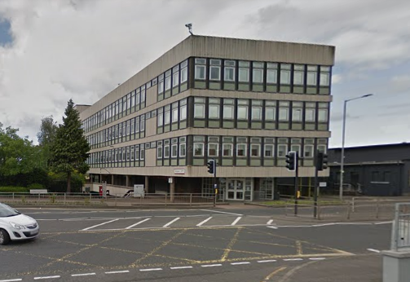 | Civic Square, Windmillhill Street, Motherwell ML1 1AB  Floors: 3 (First – Third)  Bookable desks: 160  Reception: Report to Civic Centre  Parking: Yes
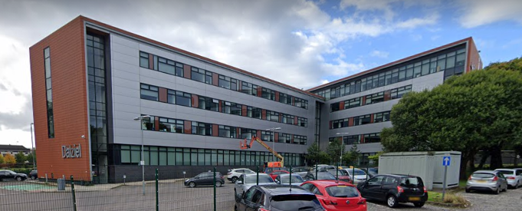 | Dalziel Building, 7 Scott Street, Motherwell ML1 1PN  Floors: 5 (Ground – Fourth)  Bookable desks: 329  Reception: Yes  Parking: Yes
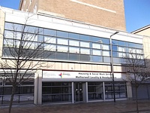 | Scott House, 73-77 Merry Street, Motherwell ML1 1JE  Floors: 6 (Ground – Fourth)  Bookable desks: 150  Reception: Yes  Parking: No
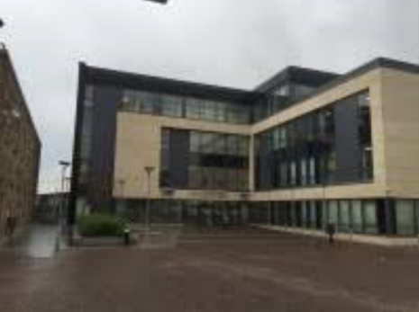 | Buchanan Centre, Main Street, Coatbridge ML5 3BJ  Floors: 1 (Ground)  Bookable desks: Limited  Reception: Yes  Parking: Yes (limited underground parking)
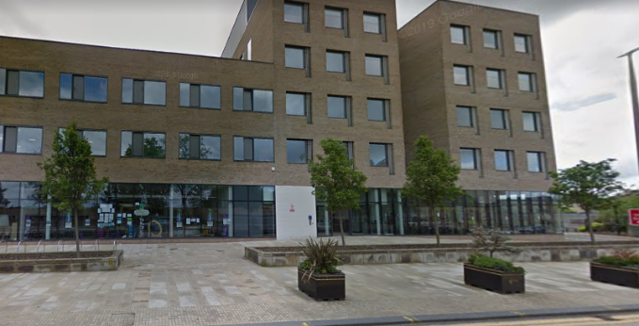 | Houldsworth Centre, Kenilworth Avenue, Wishaw, ML2 7LP  Floors: Ground and First  Bookable desks: Limited  Reception: Yes  Parking: Yes

Document Version History
Ver. # | Ver. Date | Description | Author | Reviewed By
0.1 | 10/12/2020 | Added 6 x buildings | Lynsey Downie
0.1 | 19/02/2021 | Update car parking details  Updated available floors | Lynsey Downie

